1. Upload metadata fields and file service URL : localhost:8080/upload

Input Ex:

{

"fileID" : "101",

"file" : "C://Users//rmaturi//Downloads//Sequence_Listing.raw",

"fileTitle" : "Stocks"

}

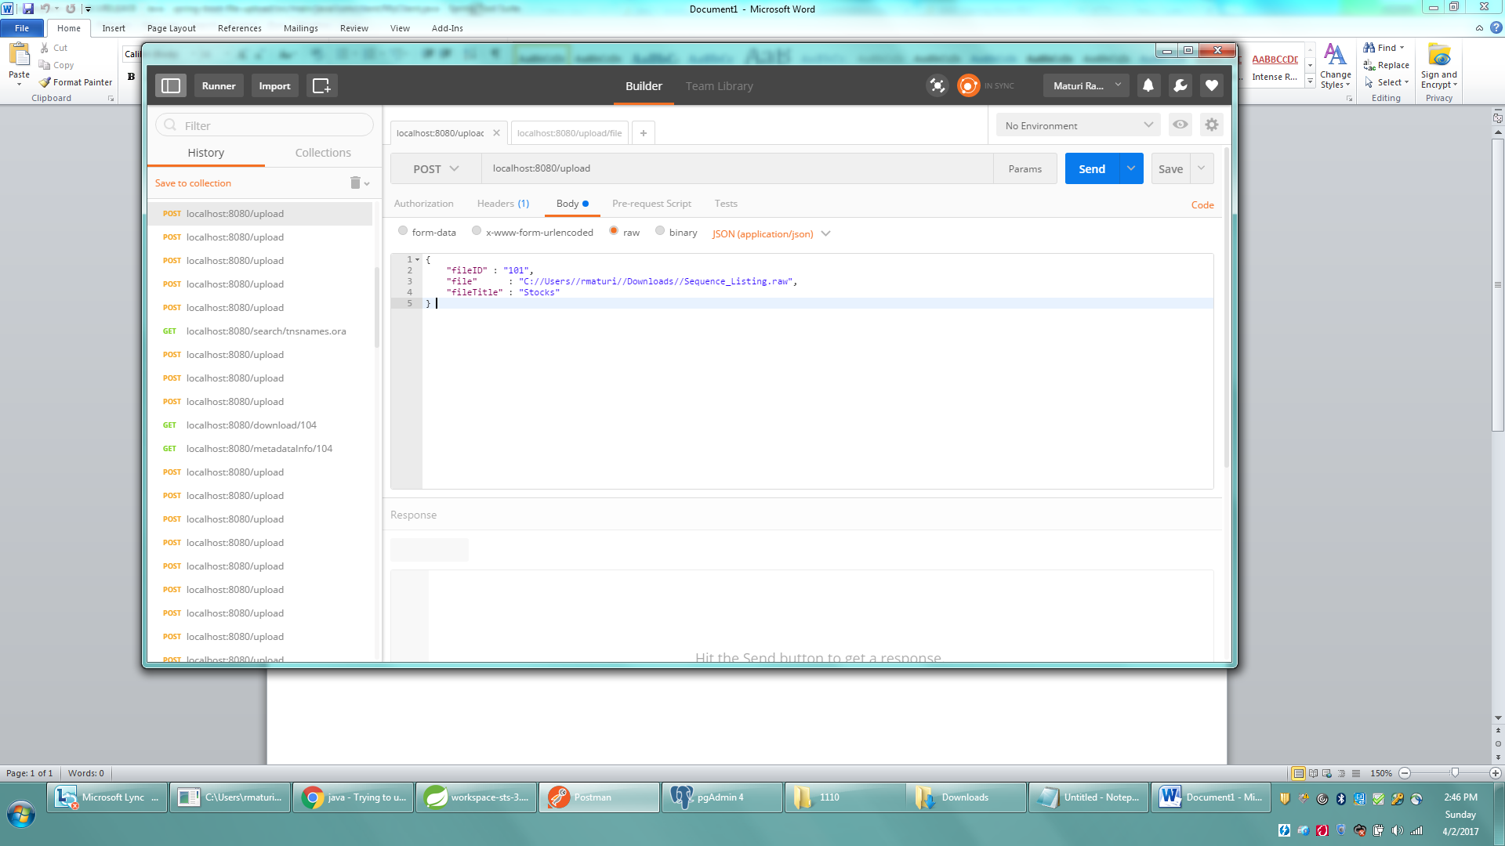

1. Get meta data of the file ID service URL: localhost:8080/metadataInfo/101

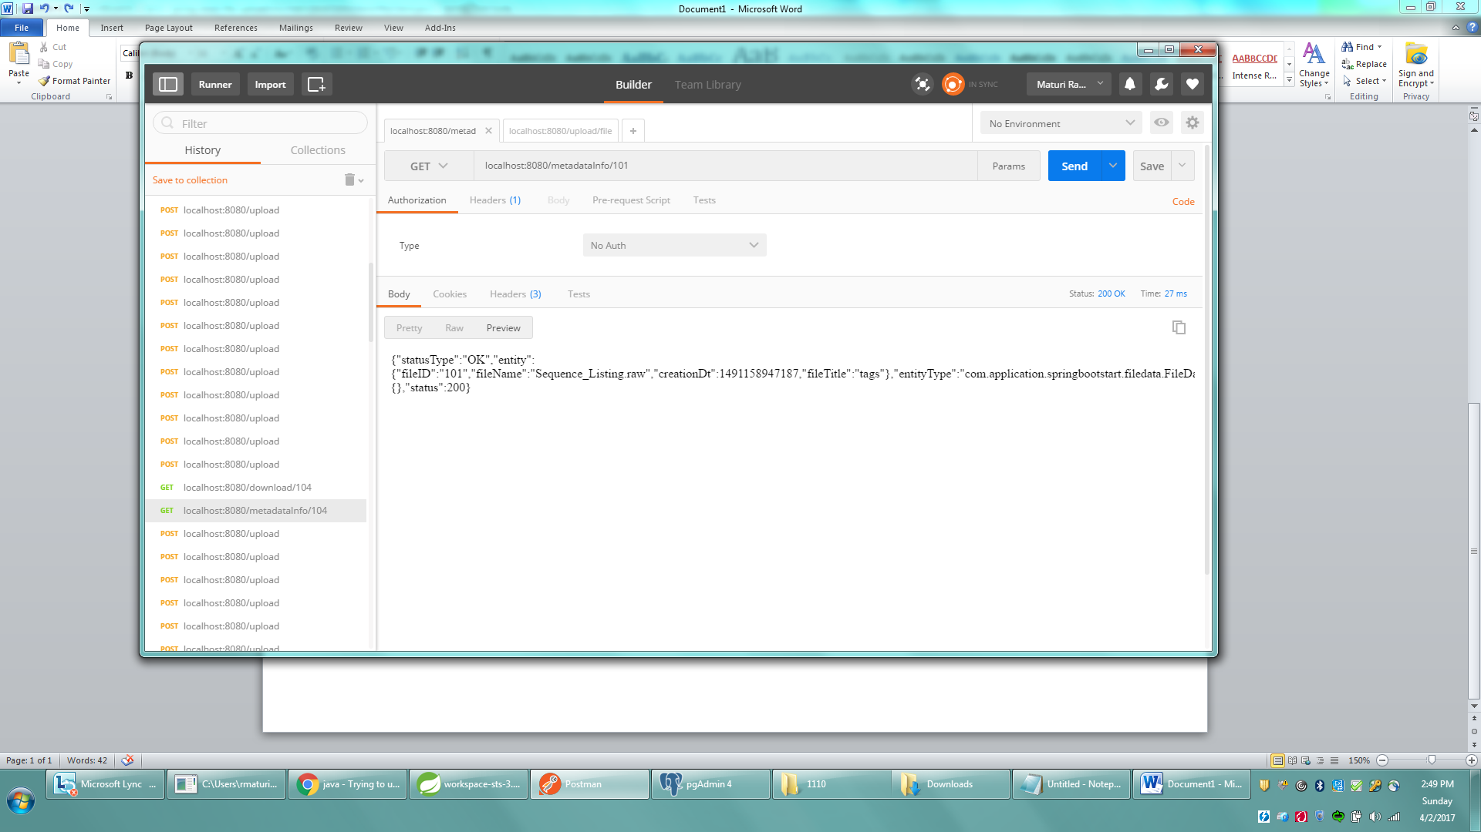

1. Download file service URL: localhost:8080/download/101
2. Search fileID’s with filename Service URL: localhost:8080/search/ Sequence_Listing.raw
3. Will get a Notification Email when in the last hour newly added fileID’s.